CMPE 280

Assignment 5

Team YYY

Team members Ajith Balaji Nagarajan (013727246)

Pooja Ramaswamy (013738868 )

Deep Khajanchi ( 013764686)

Ezana Tesfaye (013744783)

1. MongoDB database with Express and clientside support operations

Implemented Web pages showing details of Movie, Genre and Rating. User is able perform operations (from clientside) as following:

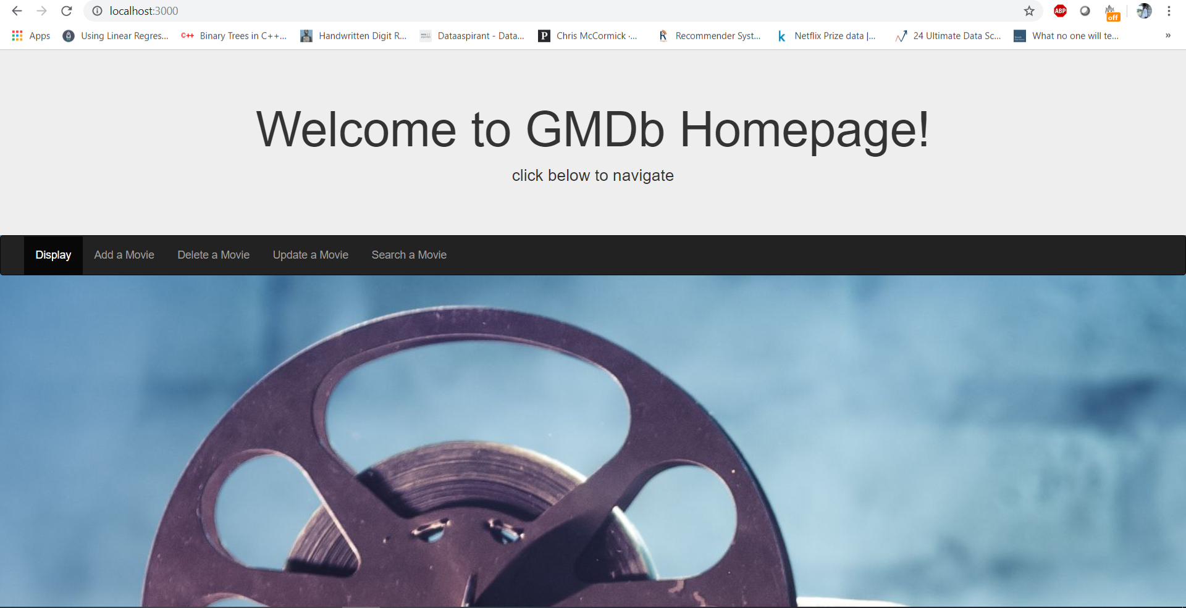

Img1: homepage of the application

(1) Display documents- Movie details stored in mongo database are showing up on the web page.

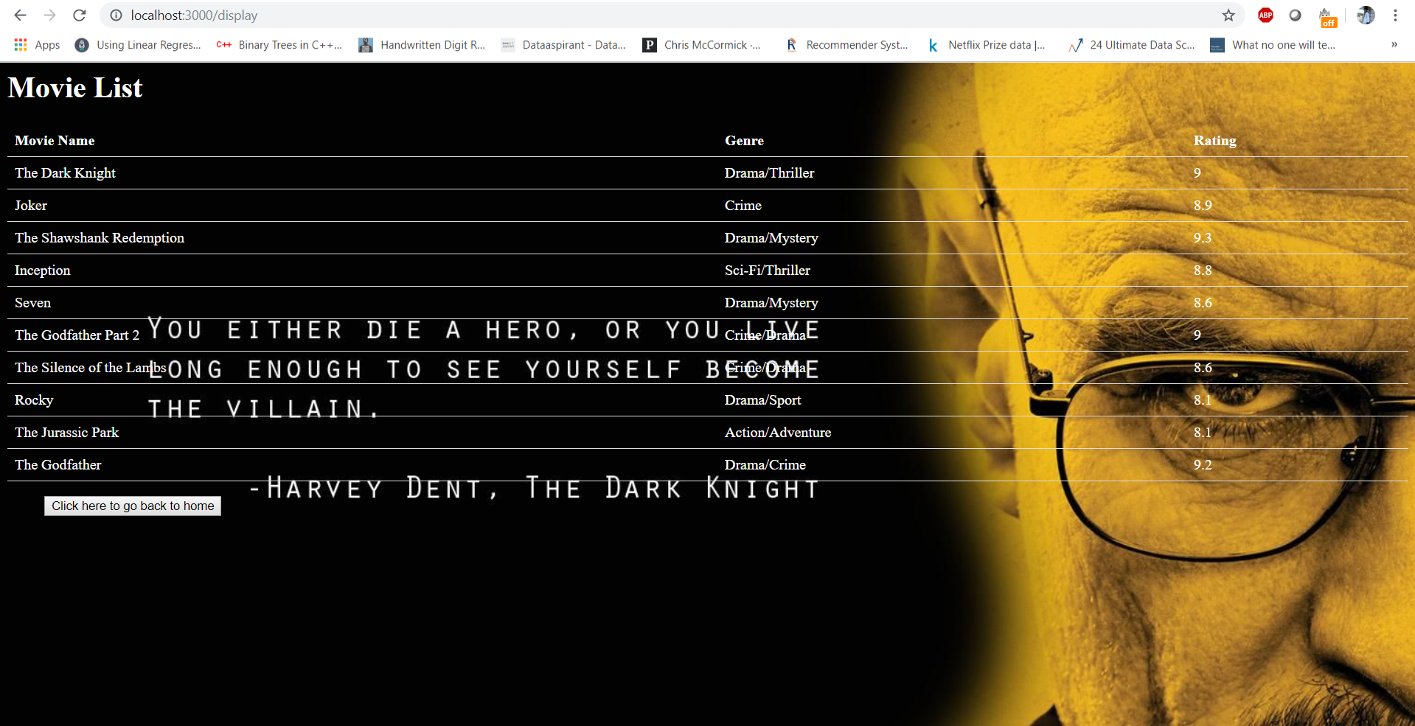

Img2: Display page which displays all the records loaded into the database.

(2) Search documents- When user searches for any particular movie name, all the details under that movie comes up. When the search fails, the user will be redirected to an error page with an error message and then the user will be given the option to redirect to the homepage or add what they were searching to the database.

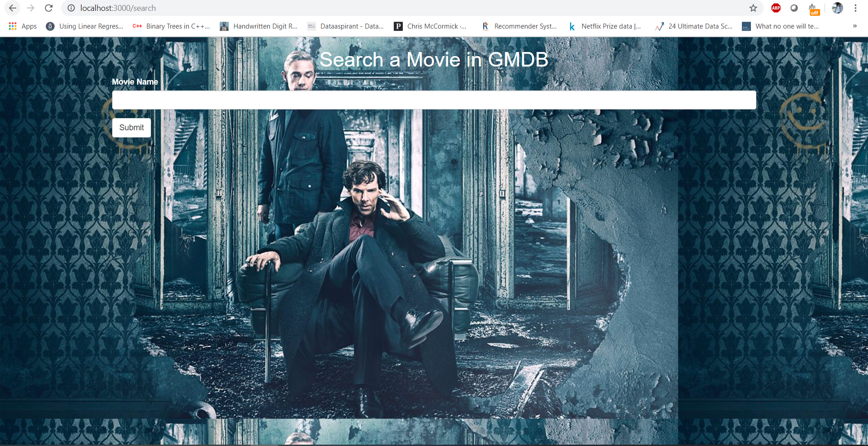

Img3 Snapshot of the search page

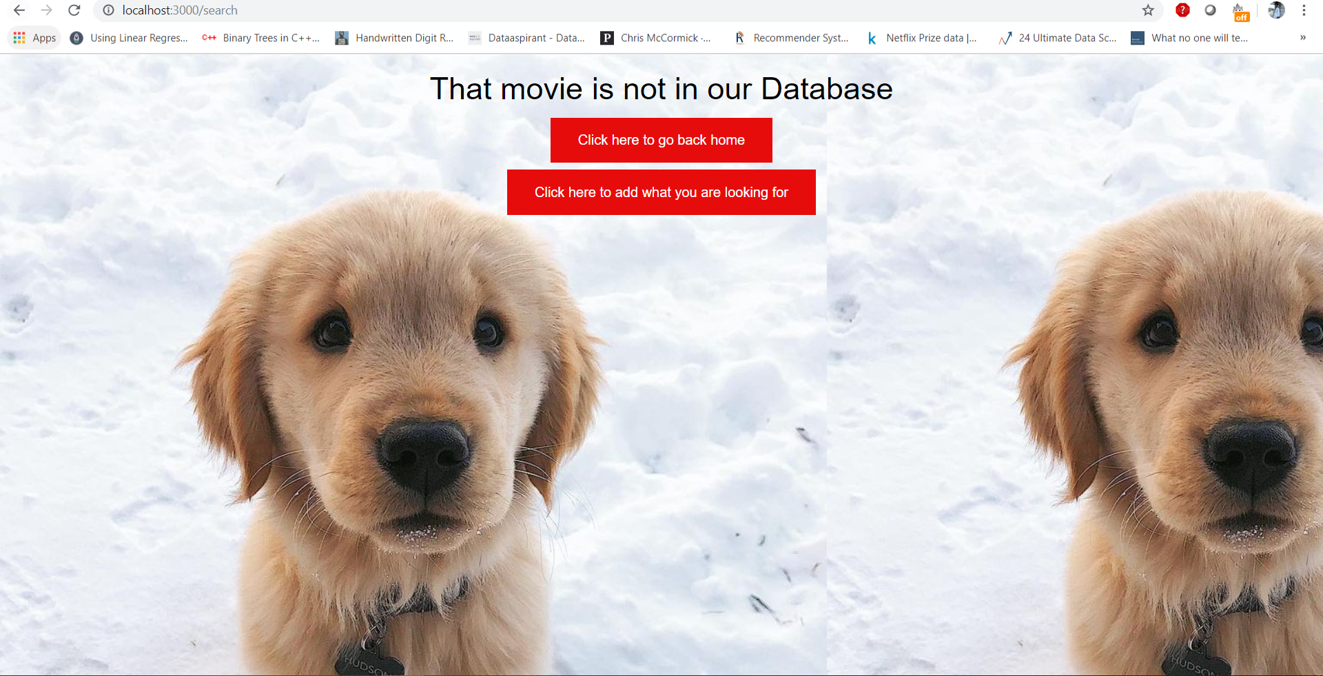

Img4 The failure page that gets rendered whenever the user enters a data that is not in the database.

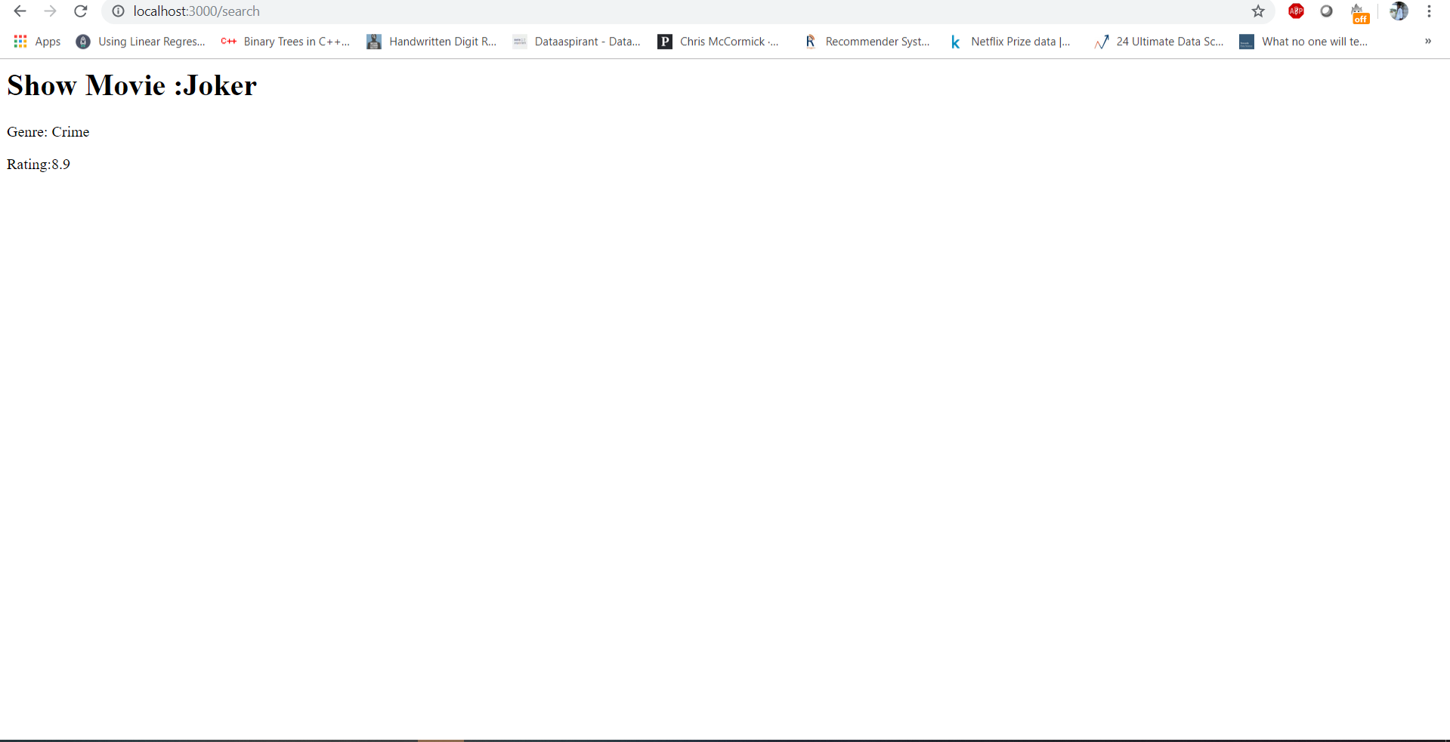

Img5 The Search success page that displays when the user enters a movie name present in the database.

(3) Add documents- Enables the user to add movie of their choice to the list of movies and the user is being provided with the option of going back to the homepage or see whether the movie they added is in the list of movies.

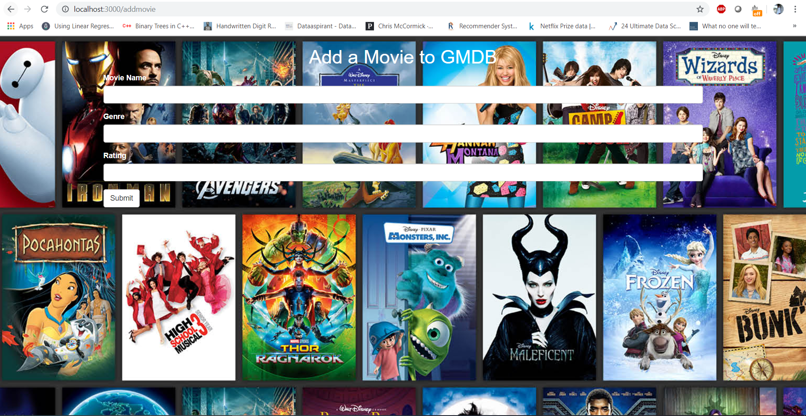

Img6 Screenshot of the add movie page, where the user can add a movie into the GMDb database.



Img7 Screenshot of the add success page

(4) Delete documents- If the user wants to remove any movie from the list then they can delete it entirely. If the record which the user wants to delete is not present in the database, they’ll be provided with the option to redirect to the homepage or add the movie to the database.

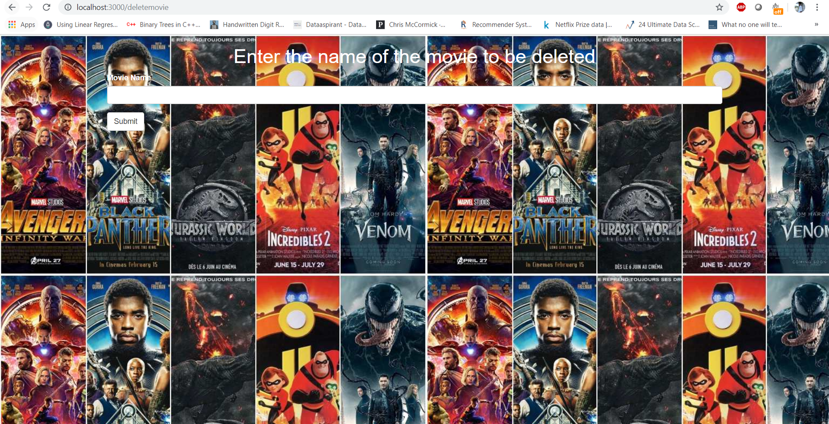

Img8 Screenshot of the delete movie page

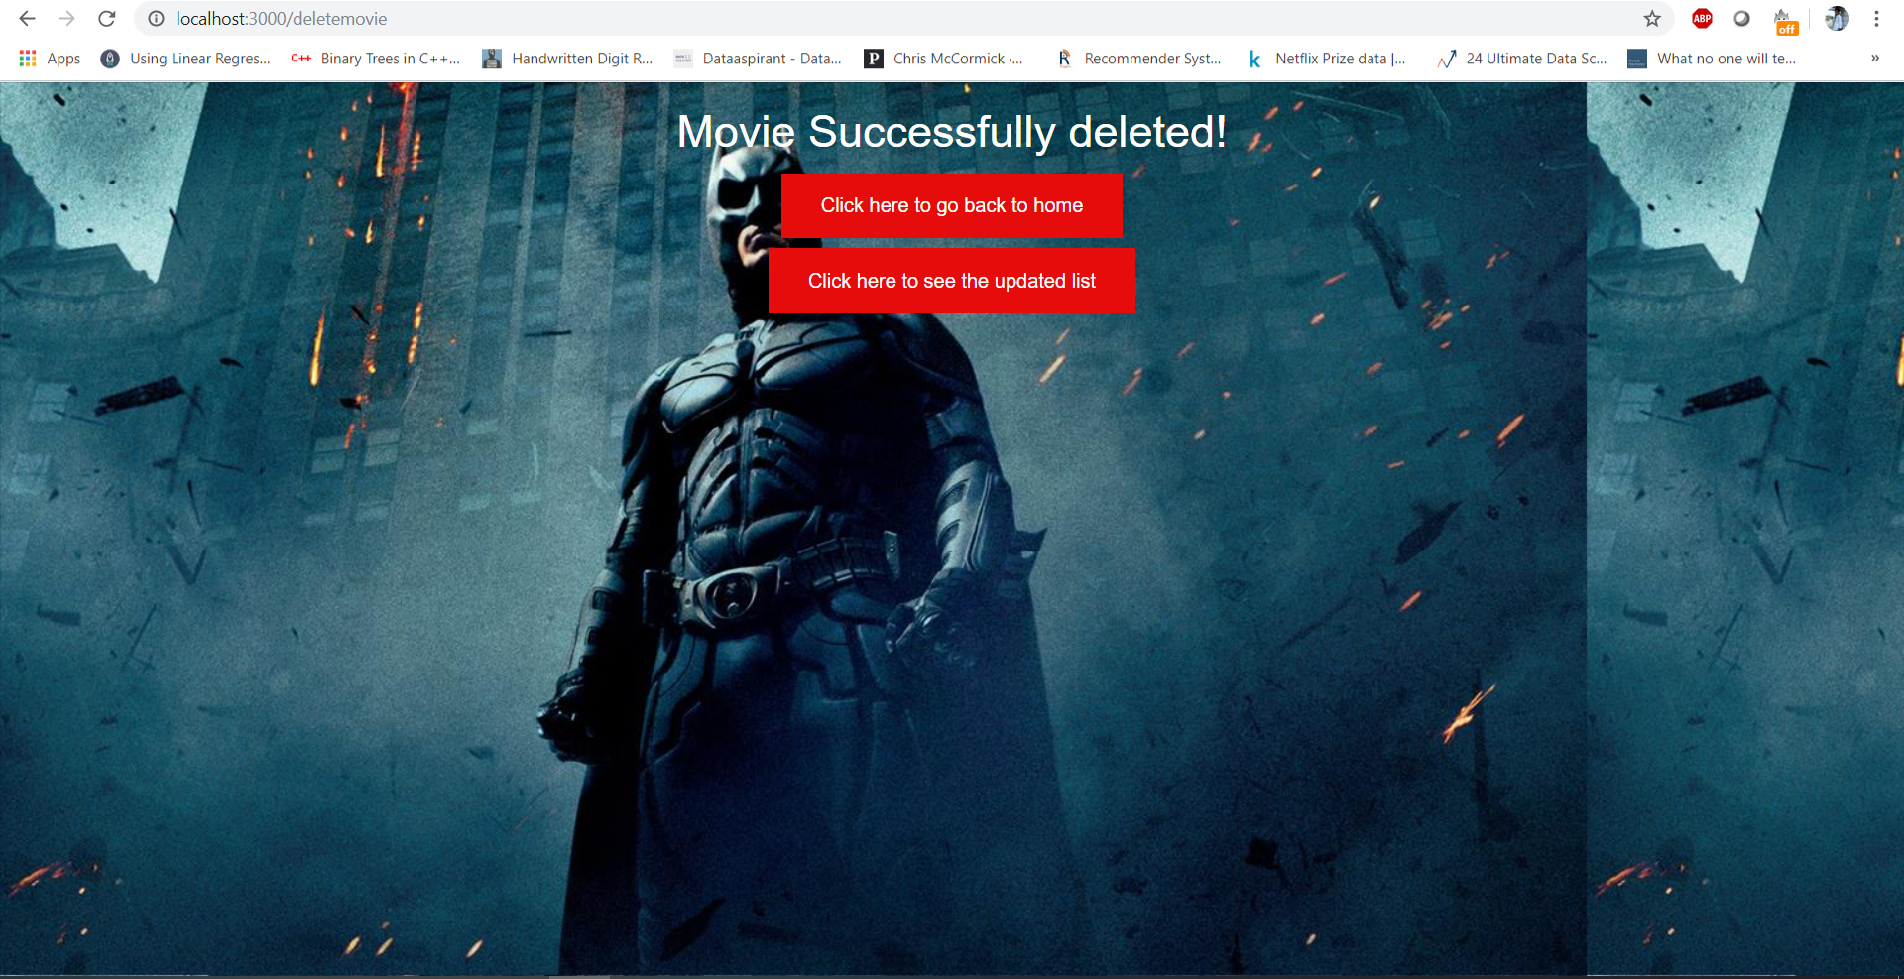

Img9 Screenshot of the movie delete page

(5) Update documents- Enables the user to update the movies in the movie list after adding to and/or deleting from existing movie list.

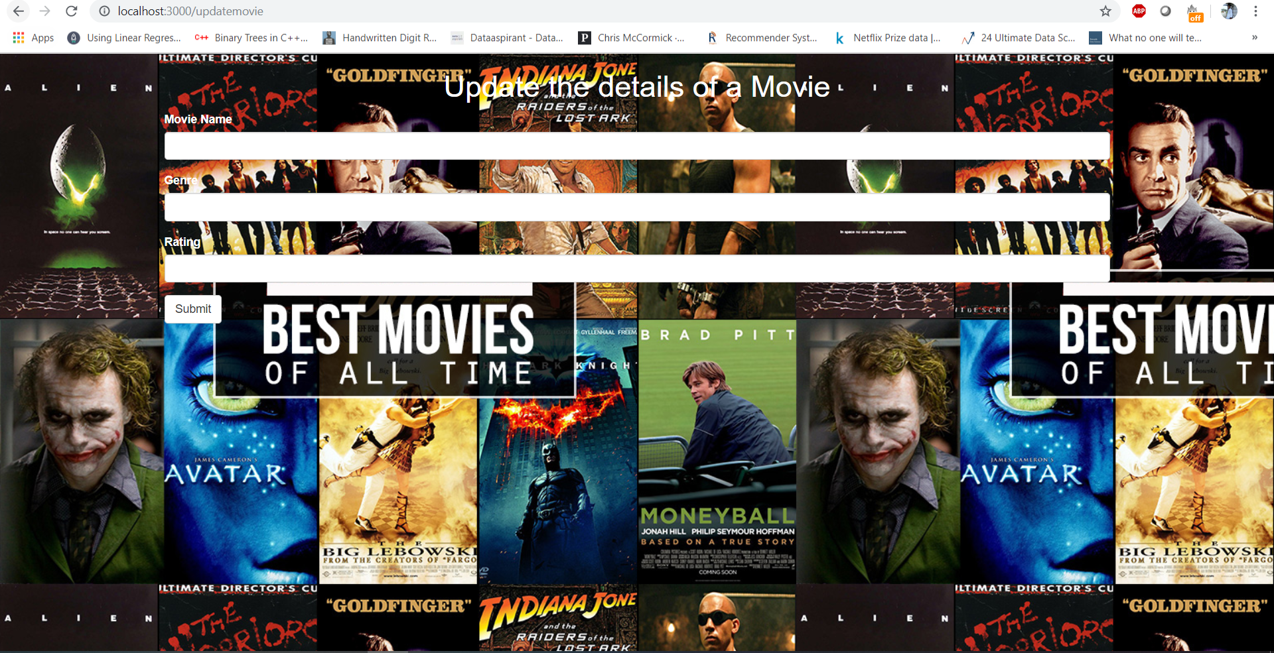

Img10 Screenshot the update movie details page

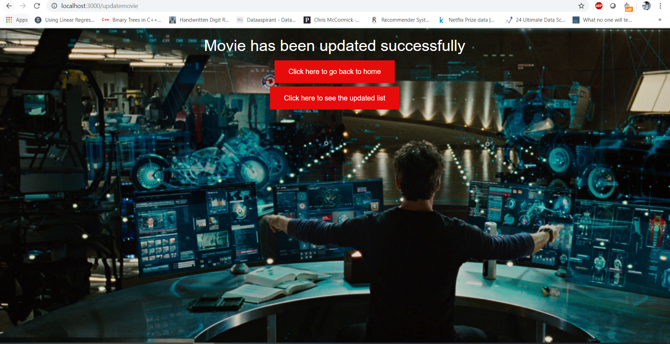

Img11 Screenshot of movie update success page

Mongodb server:

2. ETL description:

Data extraction: We searched for data and download it from kaggle website - “IMDB movie ratings” in csv file format.

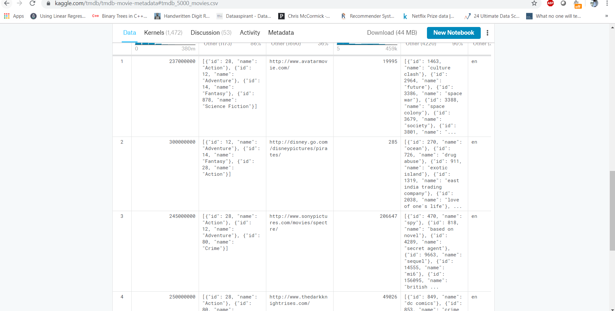

Img12 Dataset from Kaggle chosen for the final project

Data transformation: Transformation is the process of converting the extracted data from the original form into the desired form. We transformed data from .csv to .txt format in order to use them with mongo database.

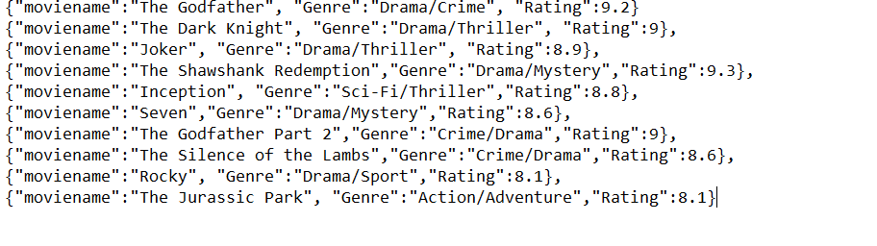

Img13 A very small subset of the original data that was chosen for the purpose of this assignment

Data load: We Loaded desired amount of data into mongo database and used them to show on web pages. To load data, we created mongodb server exposing port 27017, created database named usercollection and insert some amount of data to perform operations.

**use usercollection** to switch to collection of user’s movies database.

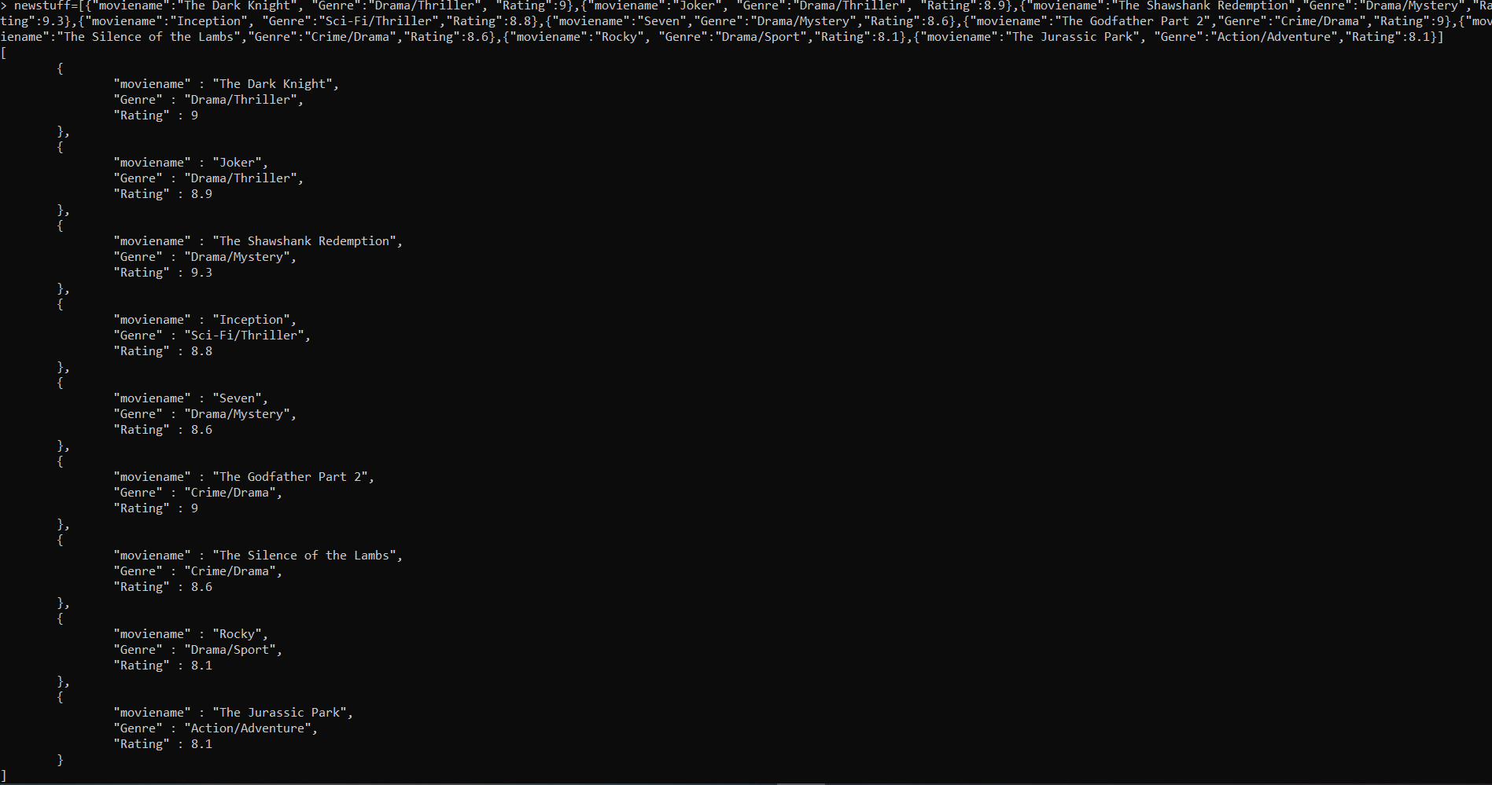

**db.usercollection.insert()** to insert data into database.

**db.usercollection.find()** to find all the loaded data in db.

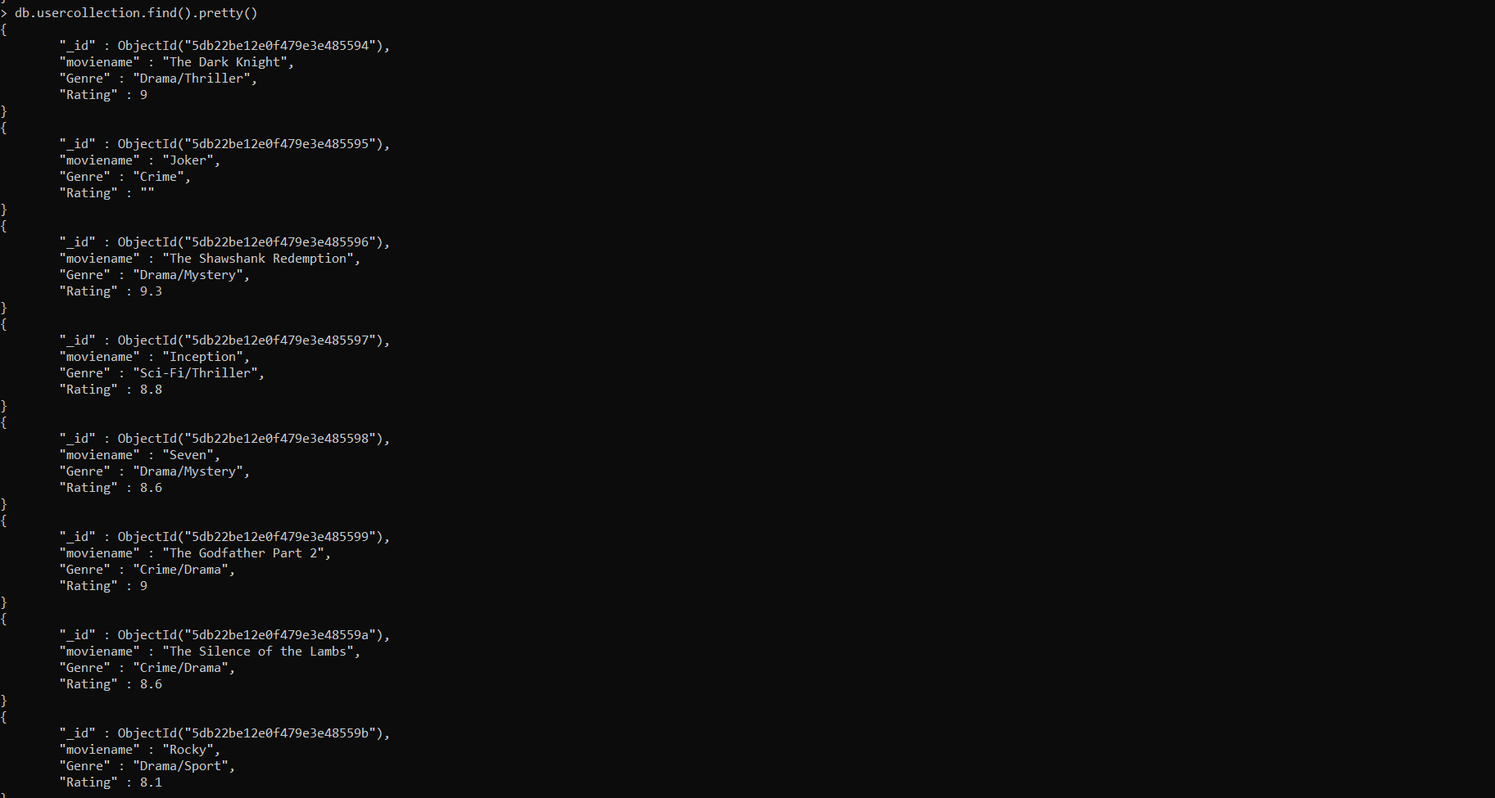

database collection name is “**usercollection**” which is being referred to model part.

**Subset of the data used in this project:**

{"moviename":"The Godfather", "Genre":"Drama/Crime", "Rating":9.2}

{"moviename":"The Dark Knight", "Genre":"Drama/Thriller", "Rating":9},

{"moviename":"Joker", "Genre":"Drama/Thriller", "Rating":8.9},

{"moviename":"The Shawshank Redemption","Genre":"Drama/Mystery","Rating":9.3},

{"moviename":"Inception", "Genre":"Sci-Fi/Thriller","Rating":8.8},

{"moviename":"Seven","Genre":"Drama/Mystery","Rating":8.6},

{"moviename":"The Godfather Part 2","Genre":"Crime/Drama","Rating":9},

{"moviename":"The Silence of the Lambs","Genre":"Crime/Drama","Rating":8.6},

{"moviename":"Rocky", "Genre":"Drama/Sport","Rating":8.1},

{"moviename":"The Jurassic Park", "Genre":"Action/Adventure","Rating":8.1}

(Note: The same will be attached to the ‘data.txt’ file along with the application.)

Directions to run the application:

1. Start Mongodb nodemon server by running the mongod application.
2. Start the Mongodb shell by running mongo.exe
3. Create the database named ‘usercollection’ in the mongodb.
4. Insert the data presented above to the usercollection database.
5. After inserting, open command prompt in the project folder and enter ‘node app.js’ or ‘npm run start’ or ‘npm start’ to start the application.
6. After that go to the browser and enter <http://localhost:3000> , this will open the homepage of the application.
7. Different menus that lead to the different pages will be displayed in the homepage.